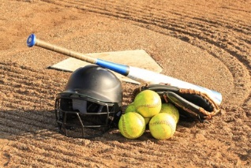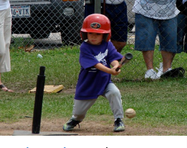

Byhalia Parks and Recreation
225 MS 309
Byhalia MS 38611
662-838-2135 ext. 122
T-ball, Baseball, and Softball Registration Form
Email all forms to ByhaliaParksandRec@townofbyhalia.com
Spring League April 1-June1 2024

Player Name ______________________________________D.O.B. __________Age now______
Address______________________________City________________State_______Zip________
Phone #______________________________Parent Name______________________________
Parent Address if different from above______________________________________________
Email Address _________________________________________________________________
T-Ball___________1st yr__________2nd yr __________3rd yr _________
Baseball ___________1st yr__________2nd yr __________3rd yr _________
Softball___________1st yr__________2nd yr __________3rd yr _________
Summer Ball Team Name?_____________________ Do you want to return to that team? Y N
Notes :________________________________________________________________________
Shirt Size Toddler Youth Adult Ball Pant Size Toddler Youth Adult
______________________________________________________________________________
Cost: $65.00 includes uniform
Make checks Payable to the Town of Byhalia
Bring Birth Certificates and Payment to Town hall 225 MS 309 Byhalia, MS 38611

Interested in coaching? Y N Interested in becoming an umpire? Y N

Signature________________________________________________Date_______________

